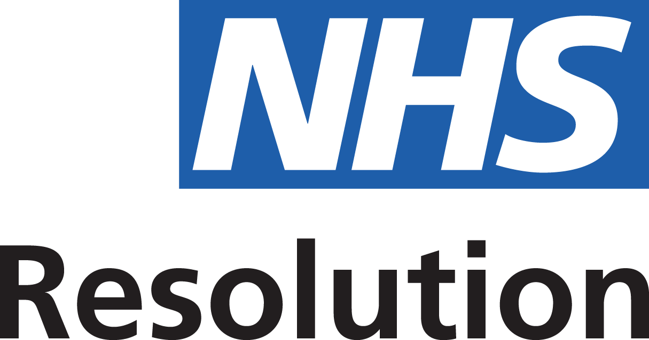

Local Training record for multi-professional ‘in-house’ maternity emergencies training day (including fetal monitoring in labour)

This form should be completed following each of your local maternity emergencies training days and submitted as evidence alongside your Clinical Negligence Scheme for Trusts (CNST) Board report

Maternity unit: | <INSERT NAME>
Date of in-house training:

Total number of staff attending local training day:

Number of midwives trained:
Band 5
Band 6
Band 7
Midwifery managers/ matrons and others (Band 8 and above)

Number of consultant obstetricians trained:

Number of obstetric trainees trained:

Number of obstetric anaesthetists trained:

Number of HCA’s/MCA’s/MSWs trained:

Number and types of other staff trained:

N.B Please attach a copy of your local maternity emergencies training day programme to this form. Thank you

