Digital Innovation in Healthcare Webinar
Tuesday 5th November 2024
Speaker biographies
Chair
Caroline Latham-Parker, Associate Safety & Learning Lead – South, NHS Resolution
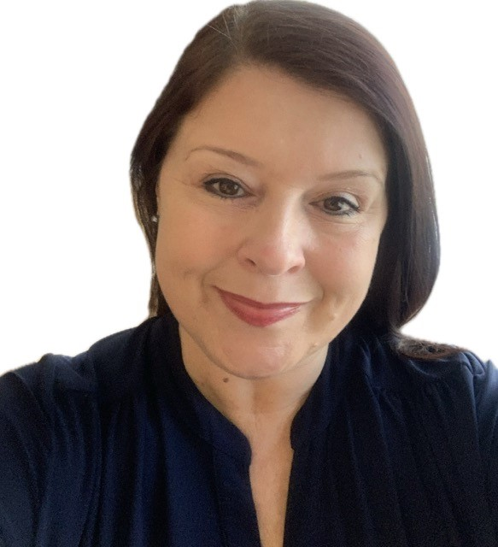 | Caroline Latham-Parker is a registered Midwife with academic attainment in Adult Nursing, Midwifery and Health Visiting. She has extensive clinical experience from both Midwifery and Health Visiting, working in both acute and community settings. Caroline has experience of leadership at team, service and system level with significant management of change for clinically facing staff, team leaders and clinical leads. During the last six years Caroline has used her clinical expertise and leadership skills to develop and monitor quality assurance. She has supported the quality improvement of healthcare services at Clinical Commissioning Group (CCG), Integrated Care System (ICS) and at regional level. In her most recent academic achievement, an MSc in Healthcare Leadership via the NHS Leadership Academy, Caroline’s interest focused on leadership behaviours, particularly the ‘Trust’ required within leadership and the impact on team effectiveness to assure patient safety at a system level. Caroline commenced her role as an Associate Safety & Learning Lead in December 2022 and is committed to supporting Trusts with learning from claims underpinned by a safety culture and prioritising improvement to have the greatest impact of patient safety.
Presentation - Digital Innovation & Automation at Portsmouth Hospital
Charlotte Taphouse - Digital Transformation Lead for the Hampshire and Isle of Wight Local Maternity and Neonatal System.
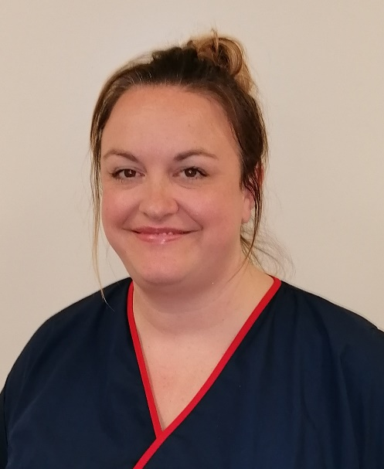 | Charlotte Taphouse is the Digital Transformation Lead for the Hampshire and Isle of Wight (HIOW) Local Maternity and Neonatal System (LMNS) leading and supporting a range of Maternity Transformation Projects. Charlotte is also a registered Midwife and continues to work at trust level as the Lead Digital Midwife. Charlotte has a passion for digital transformation and the benefits it can bring to maternity services and believes we are now in a position where well used digital systems and good quality data can be used to improve outcomes for families and support safe and robust maternity care. Prior to Charlotte’s clinical career, she completed a BA (Hons) degree in Performance Management wherein her love and passion for project management began.
Josh Clift - Associate Director of Software Development and Transformation, Portsmouth Hospitals NHS Trust
Josh Clift, the Associate Director at Portsmouth Hospital University Trust (PHUT), leads the strategic vision and implementation of intelligent automation solutions across the trust. With over 15 years of experience in global automation and artificial intelligence operations for companies like Google, Meta, and WhatsApp, he is an expert in business strategy, lean process improvement, innovation management, and digital transformation. Josh led the first fully transformative intelligent automation programme in maternity services, gaining recognition from the CQC and NHS England. Passionate about enhancing operational efficiency and patient care outcomes, he aims to make PHUT a centre of excellence for intelligent automation, improving efficiency, quality, and patient experience across the healthcare system while generating revenue for the trust.
Presentation - Legal Update
Majid Hassan – Partner Capsticks LLP
Majid is best known for his considerable expertise advising doctors, hospitals and indemnifiers in medical malpractice claims ranging from low value plastic surgery cases up to complex spinal and birth injury litigation as well as all aspects of digital health. He also handles clinical trials and product liability claims for insurers and has acted in a number of group litigation actions including the PIP breast implant litigation. He advises hospitals, private clinics and doctors as well as professional sports bodies and medical teams on clinical risk management and has lectured at national and international conferences on this topic.
Ed Glasgow - Healthcare Partner at Kennedys LLP, based in the London Office
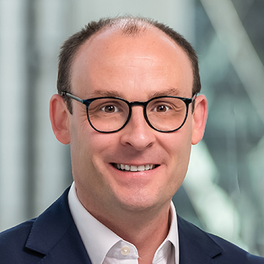 |  | Ed has served as President of the Patient Safety Section at the Royal Society of Medicine (RSM) and is now Treasurer. He has experience in advocacy, mediation, litigation, inquests, inquiries, regulatory and healthcare advisory law. His primary focus is providing expertise in resolving claims fairly, at an early stage. And, in so doing, sharing learning for improvement to assist healthcare providers. The desire being to mitigate risk, protect healthcare professionals and provide better and safer care for patients.
Presentation – Being Fair 2
Michelle Stafford – Head of Safety & Learning, NHS Resolution
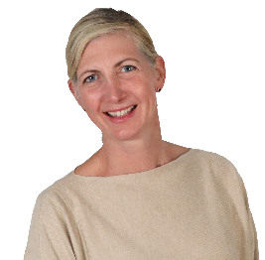 | Michelle Stafford is the interim Head of Safety and Learning. She joined NHS Resolution in 2020 and has worked in the London, South, Midlands and East regions within the Safety and Learning team. She is a registered Patient Safety Specialist and has co-authored the Being Fair 2 report and Medication Errors resources. Michelle holds a BSc (Hons) in Podiatric Medicine, a Master’s in Management and a Diploma in Diabetes Management in Primary Care. Her podiatry career has predominantly been within diabetes and vascular lower limb care. She has presented her research papers at national and international conferences. Michelle started her career in East Kent and continues to work clinically at Kings College Hospital. She has been a Clinical Network Lead for Diabetes Foot (NHS England South East) since 2019, implementing national guidance and providing regional leadership in delivering best practice in patient care.
Rob Wilson, Partner, Clyde & Co. LLP
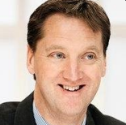 | Rob has specialised in medical defence litigation for over 20 years, acting for both medical malpractice insurers and NHS bodies. He is a Nominated Partner, with specific delegated authority, for NHS Resolution. He is ranked in the Chambers Legal Directory Clinical Negligence 'Leaders in their Field'.  Rob also has extensive inquest experience and has undertaken advocacy in a number of high-profile inquests, including prison inquests. He advised the London Ambulance Service in the inquests into the London Bombings of 7 July 2005, and has been involved in the Hillsborough inquests.  Rob frequently lectures on both medico-legal and clinical risk management issues. He has also lectured on medical litigation and inquests on Open University courses

