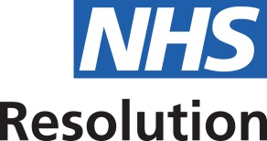

Funding allocation to successful bids in maternity, human factors, safety culture and A&E

Ten trusts submitted whole safety culture improvements which included technology, training safety leaders, communication, and trigger feedback and action systems to address patient safety issues amounting to circa. £5.2m.

Four trusts submitted bids particularly focusing on human factors education, team behaviours, communications simulation and technology amounting to circa. £1.4m.

Negotiations are underway to partner with the clinical human factors group in accordance with the Concordat agreement signed by multiple partners in December 2013 to showcase these successful bids, the projects and work undertaken and share the critical learning with the wider NHS. The planned dates for this will be early 2016.

Five trusts submitted bids relating to the Accident & Emergency specialty; focusing on improving the identification of fractures, provision of rapid image reporting and improving diagnosis of certain conditions. This mainly comprises staffing costs and training amounting to circa £0.8m.

Examples are provided below of the successful bids for four areas: maternity, human factors, safety culture and A&E. The allocation of funding for those four areas is also given:
